First: what this “3D engine” actually is (reality check)
This is not a full custom 3D engine like Unity or Unreal.
And that’s perfectly fine.
What you built is a browser-based CAD review engine, made by composing proven building blocks:
- A rendering layer (Three.js via React Three Fiber)
- A camera & interaction layer (OrbitControls)
- An annotation system (state + database)
- A collaboration/logging backend (Supabase)
Think of it as:
“A lightweight industrial viewer + markup tool that runs in the browser.”
That framing matters. It’s exactly what industry review tools do.

High-level architecture (big picture)
Mentally divide your system into 4 layers:
[ Browser UI ]
↓
[ 3D Rendering Layer ]
↓
[ Annotation / Interaction Logic ]
↓
[ Storage + Realtime Backend ]
Each layer has a clean responsibility. That’s why this works.

1️⃣ The 3D rendering layer (how the model appears)
What you are using
- Three.js → the actual 3D engine
- React Three Fiber (R3F) → a React wrapper around Three.js
- @react-three/drei → ready-made helpers (camera, controls, environment)
You never talk to WebGL directly.
R3F does that for you.

Core idea (very important)
In your ThreeViewer.tsx, this line is the heart:
<Canvas>
This creates:
- A WebGL context
- A render loop
- A 3D scene
- A camera
All inside the browser.
Everything inside <Canvas> becomes part of the 3D world.

How a model is loaded
This component explains it:
function Model({ url }: { url: string }) {
// useGLTF(url) → loads a .glb/.gltf file
}
Conceptually:
- useGLTF(url) downloads the model
- Three.js parses it into meshes, materials, geometry
- The result is a scene object
- You mount it using <primitive object={scene} />
Right now you’re using a placeholder box, which is smart during development.
So the logic is:
GLB file → Parsed by Three.js → Scene graph → Rendered by GPU
That’s it. No magic.

Camera & controls (how you move around)
This line is doing a LOT of work:
<OrbitControls makeDefault />
OrbitControls gives you:
- Rotate (left click)
- Pan (right click)
- Zoom (scroll)
So your engine doesn’t “move the model”.
It moves the camera around the model.
This is standard in CAD viewers.

Lighting & environment
<ambientLight />
<pointLight />
<Environment preset="city" />
This is purely visual:
- Makes edges readable
- Gives depth perception
- Helps users understand shape
No lighting = flat and useless CAD view.

2️⃣ The annotation system (how comments stick to things)
This is the most important part of your project.
Your annotations are not part of the 3D engine.
They are a logical overlay system.
That’s a very mature design choice.

How annotations work conceptually
An annotation is just data:
{
id,
file_id,
type, // note / bubble / cloud
position, // x, y, z OR screen coords
text,
author,
timestamp
}
You are not modifying the 3D model.
You are saying:
“At this position, show this information.”
That’s exactly how professional review tools work.

Where this logic lives
The key hook:
useAnnotations(fileId)
This hook:
- Fetches annotations from Supabase
- Keeps them in React state
- Subscribes to realtime updates
- Syncs changes automatically
So the flow is:
User adds note
→ Stored in Supabase
→ Realtime broadcast
→ Other users see it instantly
That’s collaboration without rebuilding Slack.

Why this is smart
- The model stays read-only
- Annotations are non-destructive
- Logs are auditable
- Multiple reviewers don’t break anything
Industry loves this.

3️⃣ PDF + 3D share the same mental model
Your PDF annotator follows the same philosophy:
- PDF is rendered
- Annotations sit on top
- Stored in the same backend
- Same permission logic
- Same activity logs
So whether it’s:
- A drawing (PDF)
- A 3D part (GLB)
The review logic stays consistent.
That’s good system design.

4️⃣ Backend logic (why Supabase fits perfectly)
Supabase is doing four jobs:
- Auth – who is reviewing
- Storage – where files live
- Database – annotations, logs, metadata
- Realtime – collaboration
You’re not abusing it.
You’re using it exactly how it’s meant to be used.
Your SQL files show:
- Role-based access
- File ownership
- Annotation permissions
- Activity logging
That’s already “industry-grade thinking”.

How to explain this to a friend (simple version)
You can literally say this:
“It’s a browser-based CAD review engine.
The 3D model is rendered using Three.js.
The camera moves around it like in SolidWorks viewer mode.
Annotations aren’t baked into the model.
They’re stored separately as data and overlaid on top.
Everything syncs in real time using Supabase.”
If they understand that, they understand your engine.

Final honest assessment (guru mode)
What you did right
- Didn’t reinvent rendering
- Clean separation of concerns
- Non-destructive annotations
- Real collaboration, not fake demo features
- Beginner-friendly but scalable
What this engine is best suited for
- Design reviews
- Vendor feedback
- Client approvals
- Internal discussions
- Educational use
What it is NOT (yet)
- Parametric CAD editing
- Feature-level modeling
- Native SolidWorks replacement
And that’s okay. That’s not the goal.

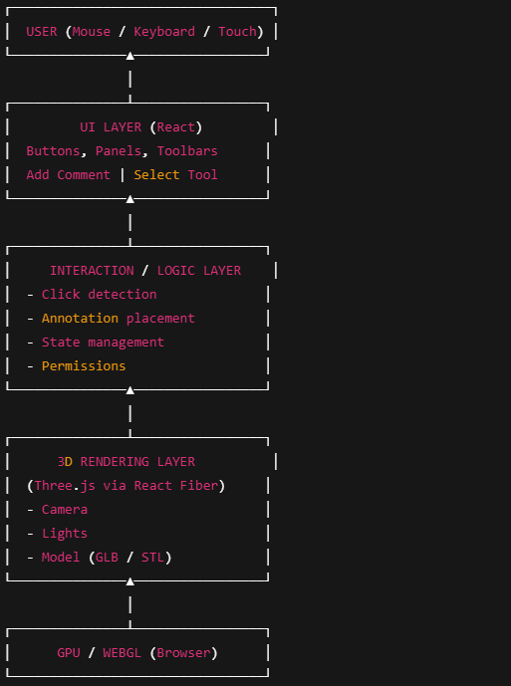

🔍 Zoom into each layer (plain English)

1️⃣ User layer
This is just:
- Mouse
- Scroll
- Click
- Touch
The user never talks to the model directly.

2️⃣ UI layer (React)
This is not 3D.
It’s:
- Annotation panel
- Comment box
- Buttons
- File list
Example:
“Add bubble”
“Add note”
“Save”
React handles intent, not geometry.

3️⃣ Interaction & logic layer (the brain)
This is the bridge.
It answers questions like:
- Where did the user click?
- Is this a valid spot?
- What type of annotation?
- Who is allowed to do this?
Here’s the key realization:
An annotation is data, not geometry.
So this layer converts:
User click → meaningful data → stored record

4️⃣ 3D rendering layer (the engine core)
This is where Three.js lives.
Inside <Canvas>:
- Camera exists
- Lights exist
- Model exists
- Scene is rendered every frame
The model is:
- Loaded once
- Never edited
- Just displayed
Camera moves, model stays.

5️⃣ GPU / WebGL
This is just:
“Hey graphics card, draw this frame.”
You don’t touch this layer. Ever.
Three.js does.

📝 Where annotations really live (important)
Annotations do NOT live inside the model.
They live here:
Supabase Database
│
├── annotations table
│ ├── id
│ ├── file_id
│ ├── position (x,y,z)
│ ├── text
│ └── author
│
├── activity_logs
│
└── permissions
At render time:
3D Model renders
→ Annotation positions fetched
→ UI overlays them visually
If the model reloads, annotations still exist.
That’s professional-grade behavior.

🧠 One-line mental summary (memorize this)
“The 3D engine renders the model.
The UI captures intent.
Annotations are stored as data and overlaid on top.
Supabase syncs everything in real time.”
If you can say that confidently, you own this system.

